Aim:

* Design a Programmable Digital Data Display system.

**Circuit diagram:**

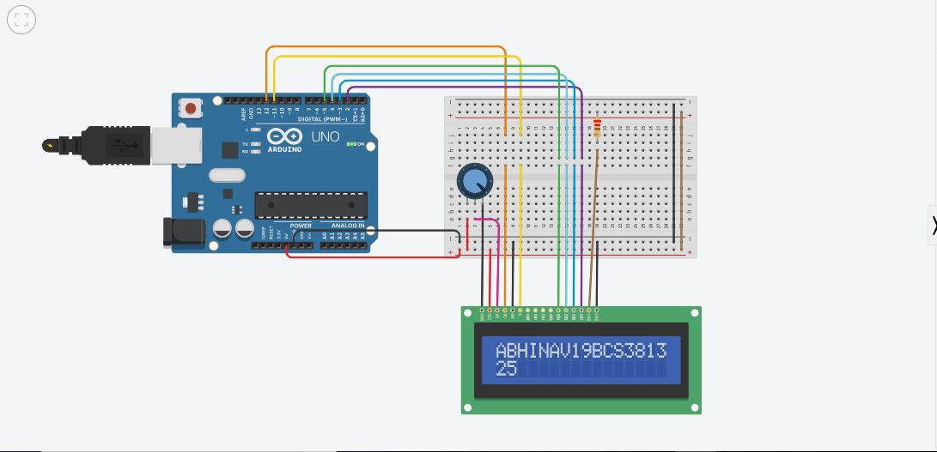

**Theory:**

**Concept used:**

* **By using kirchoff’s voltage law**

**&**

* **By using kirchoff’s current law**
* **Series or parallel connections**

**Learning and observations:**

* **Connections in Breadboard and wiring.**
* **How to control arduino and its coding.**
* **Use of multimeter for continuity.**
* **All pinmode of lcd connect in proper pinmode of arduino as mention in LCD.**
* **Use of potentiometer.**
* Liquid Crystal Display

LCD (**Liquid Crystal Display**) is a type of flat panel display which uses liquid crystals in its primary form of operation. LEDs have a large and varying set of use cases for consumers and businesses, as they can be commonly found in smartphones, televisions, computer monitors and instrument panel.

# POTENTIOMETER:--

A **potentiometer** is a three-terminal resistor with a sliding or rotating contact that forms an adjustable voltage divider. If only two terminals are used, one end and the wiper, it acts as a **variable resistor** or rheostat.

**OBSERVATION:**

* **Observe the programme which is displaying on LCD.**
* **Relation between software and hardware.**
* **Use of potentiometer.**

**Problems & Troubleshooting:**

* **To select the right port and type of arduino.**
* **To check the loose connections.**
* **To check the connections according to the codes.**
* **To check the continuity of the circuit.**
* **To check the flow of current in the circuit.**
* **To check the pinmode of lcd and connect it to arduino pinmode properly.**

**Precautions:**

* **Handle tools carefully.**
* **Wear gloves .**
* **Do not connect arduino till the circuit is complete.**
* **Do not connect direct power supply to arduino.**

**Outcomes:**

**Display our programme on LCD.**

**By using potentiometer.**